Python Programming

Experiment Report

Name DIO STANIA ADINATA
Student Number
Major Software Engineering
Class 2023

2022

Experiment 1

- Experimental Purpose
Experiment w aims to familiarize the student with python by completing list of objectives:
  - Master the usage of variables in Python programming
  - Learn how to declare, assign, and modify variable values.
  - Learn how to use expressions for arithmetic calculations.
  - Practice input/output operations and data type handling.
- Experiment Content
  - Objective1: Installing Python
    - Design thought
I plan to create a Python program that demonstrates variable assignment and modification. The program will accept an integer input from the user, the input will be stored in a variable named "num". In the program the value of the variable is modified to 50, so when the program is running, instead of showing the input value, it will show the modified value.
    - Source Code
num = int(input("Enter an integer: ")) num = 50
print("Result:", num)
    - Experiment Result

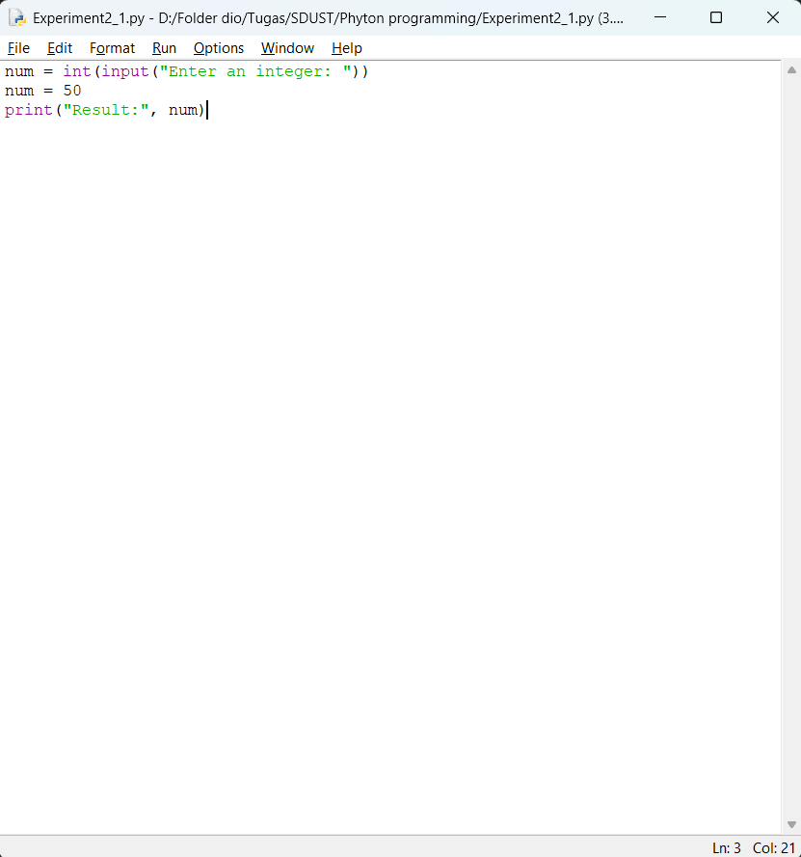
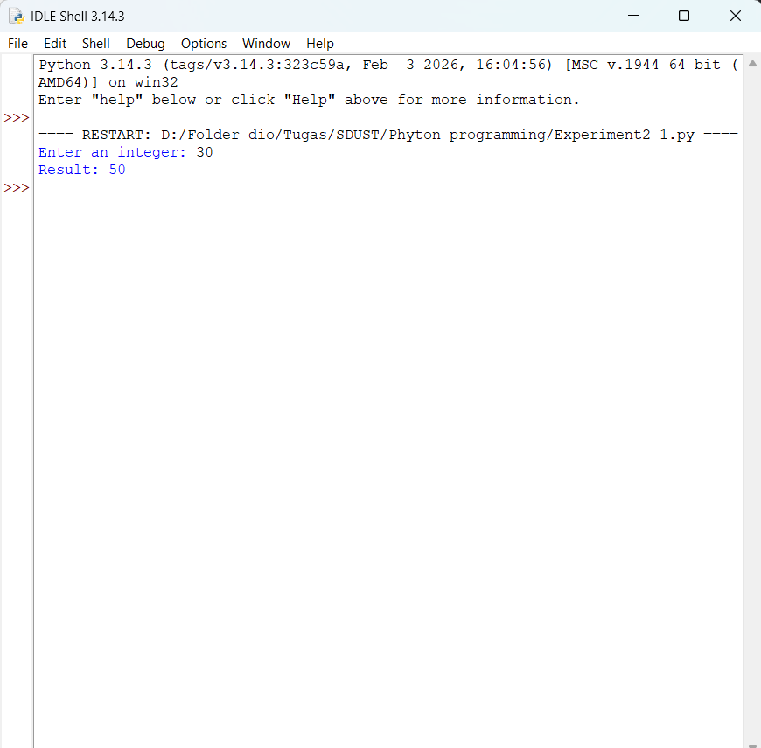

  - Objective2: Install a Third-party Library

    - Design thought
I plan to create a Python program that will prompt the user to enter two number, the value will store in 2 separate variables. Then I use expression to calculate their sum and multiplication, it will display both calculation results to demonstrate arithmetic operations
    - Source Code
num1 = int(input("Enter first number: ")) num2 = int(input("Enter second number: "))

sum_result = num1 + num2 multiply_result = num1 * num2

print("Result sum:", sum_result)
print("Result multiplication:", multiply_result)
    - Experiment Result

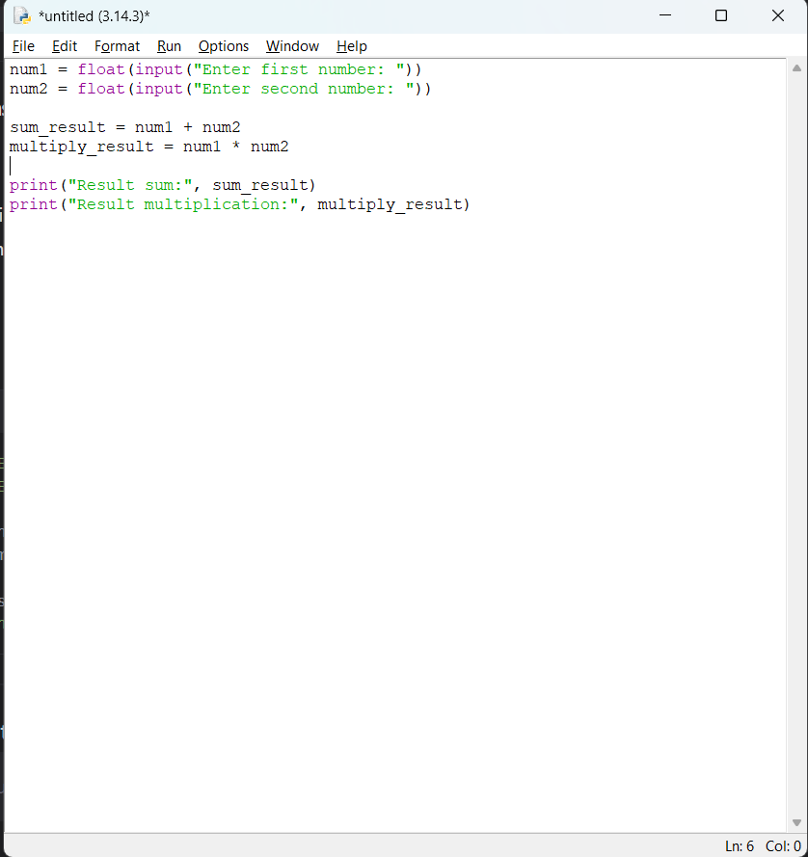
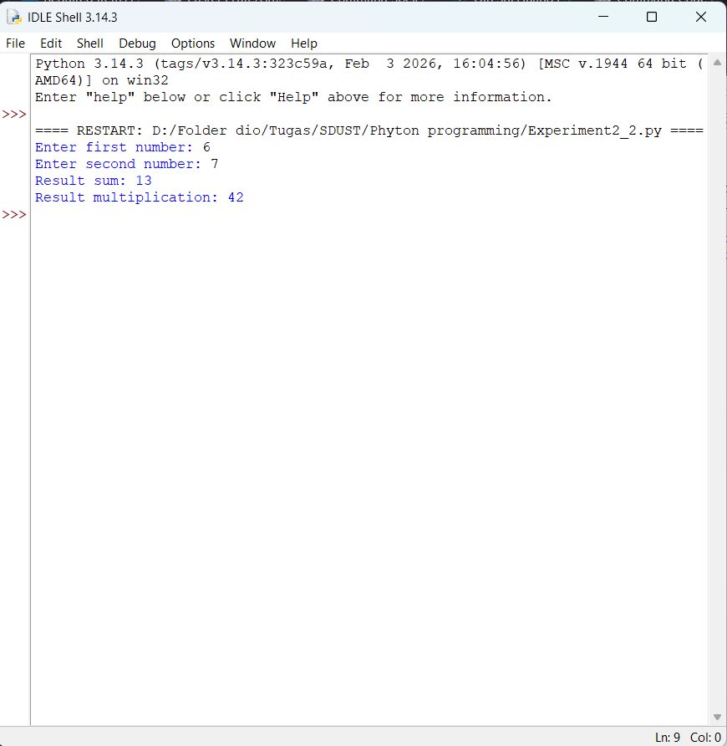

  - Objective3: Interactive Mode Practice
    - Design thought
I plan to create a Python program that imulates a store purchase calculation, the program will ask the user to enter the price of five different items, then the program will calculate the subtotal of all items, after that it will calculate the sales tax using 7% rate. Then it will calculate the total sale amount, the total sale will be displayed in the program.
    - Source Code
item1 = float(input("Enter price of item 1: ")) item2 = float(input("Enter price of item 2: ")) item3 = float(input("Enter price of item 3: ")) item4 = float(input("Enter price of item 4: ")) item5 = float(input("Enter price of item 5: "))
subtotal = item1 + item2 + item3 + item4 + item5 #Subtotal tax_rate = 0.07
sales_tax = subtotal * tax_rate #Calculate sales tax (7%)
final_price = subtotal + sales_tax # Calculate total #Display results
print("Amount of purchase: $", subtotal) print("Sales tax (7%): $", sales_tax) print("Final Price: $", final_price)
    - Experiment Result

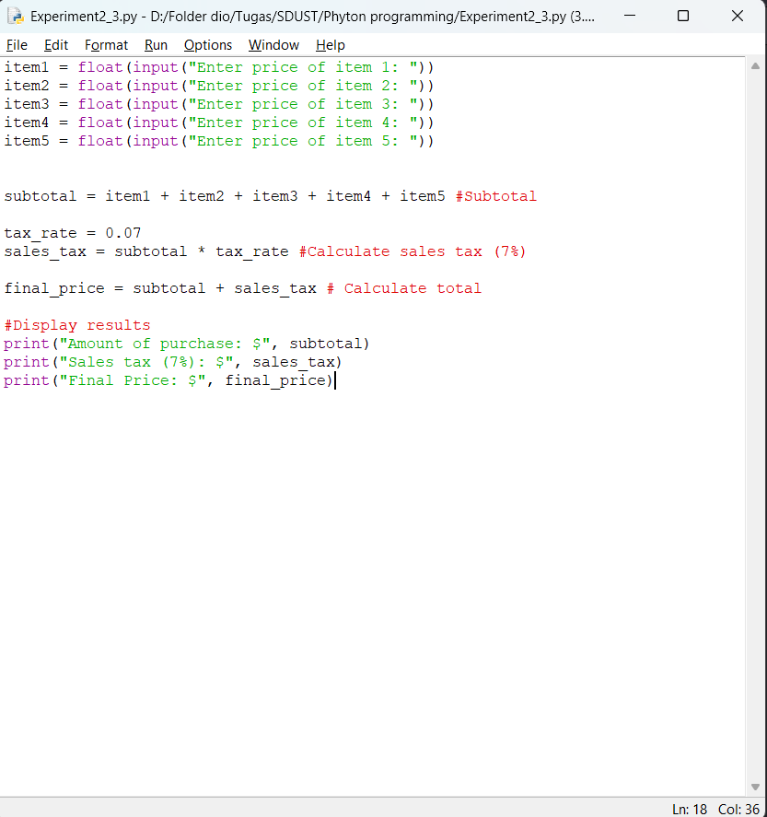
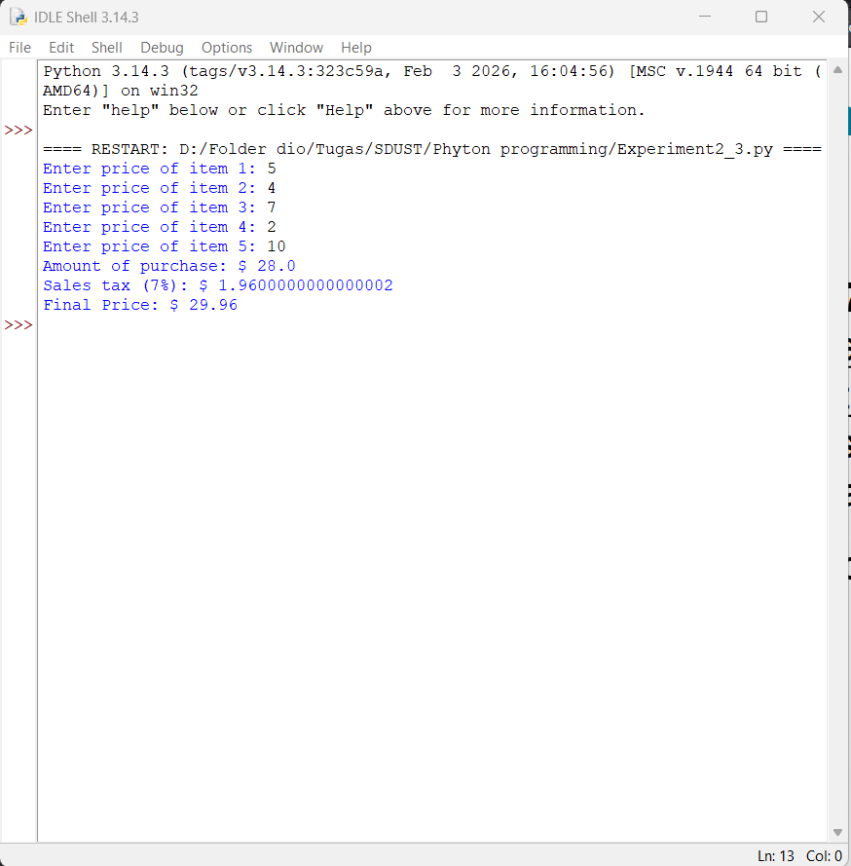

- Experiment Conclusion
What did you learn from the experiment?
From this experiment I learned several important concepts in Python programming. I understood how to declare variables, assign values, and modify their value during the program execution. I also learn about different data types, particularly integers and floats, and how to convert user input (which is initially a string) to numeric types using int() and float() functions. I practiced using arithmetic expressions with operators like addition (+) and multiplication (*) to perform calculations, this expressions combine variables and values to produce new results. Lastly, I more familiarized with the input() function to receive user data and print() function to display result.

